# **ITS2** MiSeq Sample Prep

Created by C. Kenkel, edited by Sarah W. Davies on July 5th, 2015.

Adapted for Boston University by Nicola G. Kriefall & Hanny E. Rivera on July 3rd, 2019.

This protocol was developed to amplify single sequence products via the MiSeq platform to gauge within-sequence diversity of the ITS2 region. However, this protocol can be applied to any amplicon sequencing application. It is important to start with a large template amount to include all the sequence diversity that exists. Cycle checking avoids over-amplification of products, which can result in anomalous sequences and over/under-representation of specific products. PCR clean-up following the initial amplification removes “short” primers so that the barcoded MiSeq primers can be added without resulting in concatenated products in the second PCR step. Since the identity of each sample is preserved through the barcode sequence, samples can be pooled for sequencing.

**Protocol Summary**

|  |  |
| --- | --- |
| **Step** | **Sample Volume/Notes** |
| ITS2 initial PCR | 3µl of DNA extract, 30 µl total rxn  (Can lower to 2µl & 20µl once you get comfortable) |
| Visualize on gel | Use 2µl of PCR product |
| PCR cleanup 1 | Elute in 30µl |
| Denovix | 1µl for measuring |
| Normalize all samples to 10 ng/µl (optional) | Variable |
| Barcoding PCR | 2µl of cleaned product, 20µl total rxn |
| Visualize on gel | Use 2µl of PCR product |
| Pool samples based on band intensity | Variable |
| PCR Cleanup 2 | Elute in 40µl |
| Gel extraction | Use taped wells, SYBR Green gel, run 20 µl of library on gel, cut out band |
| Incubate gel band overnight | 20µl of sterile, nuclease free water |
| PicoGreen for library concentration | Transfer liquid from extraction into new tube. Use 2µl for PicoGreen read out |

# Overview:

# PCR amplification of ITS2 region

# Barcoding of ITS2 amplicon

# Pooling your samples & gel extraction

# P5-P7 test to check that gel extraction worked

# Submit for sequencing!

# Protocol:

# PCR amplification of the ITS2 region

1. Dilute your DNA samples down to 10 ng/µl each using the same solution your DNA was isolated in.
2. Get ice.
3. Collect the following reagents:
   1. ExTaq enzyme (KEEP ON ICE **ALWAYS** – DEGRADES AT ROOM TEMP)
   2. dNTPs (2.5mM)
   3. ExTaq Buffer (10x)
   4. MilliQ water or molecular grade water
   5. ITS2 forward primer (stock is 100µM)
   6. ITS2 reverse primer (stock is 100µM)
      1. Make a 10µM primer stock that combines the forward & reverse primers by combining the following:

50µl ITS2 forward (100µM)

50µl ITS2 reverse (100µM)

400µl MilliQ water or molecular grade water

gives you a 500µl primer stock of 10µM forward + reverse

1. Put all the reagents on your bench to thaw at room temperature, except for the ExTaq enzyme of course – KEEP ON ICE **ALWAYS**.
2. While the reagents are thawing, label PCR tubes (the very tiny, attached ones) with all your sample names on the top AND sides (marker can get removed by the PCR heat later).
3. Once reagents are thawed, mix via flicking or vortexing and then spin down for 2 seconds at your bench.
   1. Only flick the ExTaq enzyme, don’t vortex, it’s fragile
4. Label a new tube “MM” (short for “Master Mix”). This tube needs to be able to hold at least 27µl x the number of samples you have.
5. Write down your PCR ingredient list & then do your math for the recipe, adding in an additional half of a sample for pipette irregularities. If it’s your first time, please get a second set of eyes on the master mix math to ensure that you have not made a mistake.

**Master Mix Recipe**

Reagent (1x)

H2O 18.6µl

10x ExTaq buffer 3.0µl

2.5 mM dNTPs 2.4µl

10µM F+R primer 3.0µl (can also start with 1µM stock – I find 10µM works better)

ExTaq enzyme 0.15µl

Total: 27µl/reaction plus 3µl (10ng/µl) DNA sample = **30µl total**

**Note**: this really adds up to 30.15µl but the ExTaq enzyme is negligible so don’t math it

Example math for 8 samples:

Reagent (8.5x)

H2O 158.1µl

10x ExTaq buffer 25.5µl

2.5 mM dNTPs 20.4µl

10µM F+R primer 25.5µl (can also start with 1µM stock – I find 10µM works better)

ExTaq enzyme 1.28µl

Total: 229.5µl total (27µl/reaction x 8.5 reactions)

**Note**: this really adds up to 230.78 but the ExTaq enzyme is negligible so don’t math it

1. Add in each ingredient to your “MM” tube in the order above (least expensive 🡪 most expensive just in case you mess up).
2. Once all your ingredients have been added, flick to mix and then spin down.
3. Add 27µl of MM to each of your labeled PCR tubes using the same tip. Be careful not to produce bubbles.
4. Carefully add in 3 µl of your sample DNA (10 ng/µl) ensuring that DNA has entered and left the tip into its correct respective tube. Change tips for each sample.
5. Flick & spin down PCR tubes, do a quick visual check that they all have the same volume.
6. Put PCR tubes in PCR machine.

**ITS2 PCR Profile**

26x 95°C for 40s

59°C for 2min

72°C for 1min

72°C for 7min

1. Check the time that the PCR will finish & set an alarm.
2. While the PCR is running – make a 1% agarose gel.
3. When the PCR is finished – run 2µl of each sample on the gel at 180mV, 270mA for 20 minutes. Take VERY SPECIFIC notes of the order in which you loaded the samples.
4. 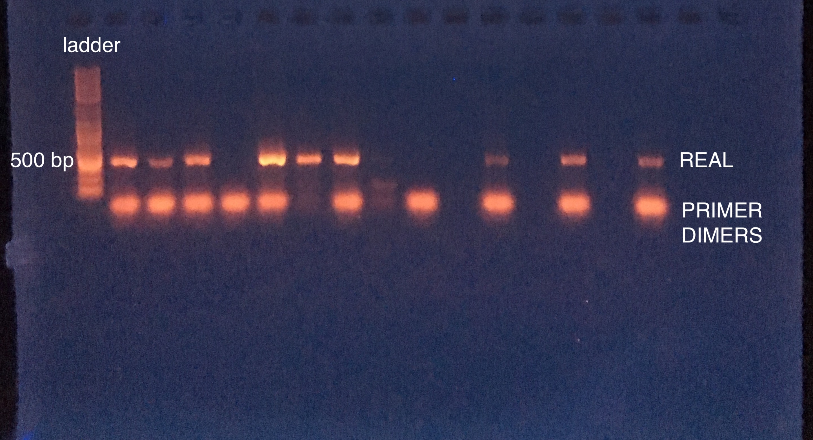Take a picture of the gel & upload. Your bands should look like this:

Most of these amplifications were successful (“REAL” bands). The 4th, 8th, and 9th lanes didn't work & I didn't load anything in the 10th, 12th, and 14th lanes.

1. If 26 cycles didn’t work, try again with 30 cycles. If that didn’t work, try again with 35 cycles. NEVER DO MORE THAN 35 CYCLES FOR PCR – NOT REAL AMPLIFICATION.

Other troubleshooting options:

* Play around with primer concentration. If 10µM stock didn’t work well – do a 1µM stock, or vice versa.
* Try less or more DNA template.
* Try adding more ExTaq buffer (has good things for PCR in it).
* Try cleaning your genomic DNA using the Zymo DNA clean & concentrator kit.
* If all else fails, try re-extracting the DNA from your tissue sample.

1. For each successfully amplified ITS2 sample, clean it using the GeneJET PCR Purification Kit. Elute in 30µl of elution buffer.
2. (Optional) for each cleaned sampled, nanodrop & dilute in elution buffer as necessary to reach 10ng/µl for each sample. If you don’t do this step, you can just add 2µl of each sample for barcoding without checking the concentration – you may get less uniform results but it should still work.

# Barcoding of the ITS2 amplicon

* + 1. Get ice.
    2. Collect the following reagents:

1. ExTaq enzyme (KEEP ON ICE **ALWAYS** – DEGRADES AT ROOM TEMP)
2. dNTPs (2.5mM)
3. ExTaq Buffer (10x)
4. MilliQ water or molecular grade water
5. MiSeq barcoded adapters 96-well plate (1µM)
   * 1. Thaw reagents at room temp, besides keeping ExTaq enzyme on ice. Flick & spin down all reagents. For the MiSeq barcoded adapters plate, ALWAYS spin it down in the plate spinning machine before you lift the lid off.
     2. Label a new “MM” tube (must be able to hold 15µl x the number of samples you have) & do the master mix math: multiply by number of your samples + ½ of a sample, same as in amplicon PCR. So, if you have 8 samples, multiply the following master mix numbers by 8.5 & add to “MM” tube:

**Master Mix Recipe**

Reagent (1X)

H2O 11.4µl

10x ExTaq Buffer 2µl

2.5mM dNTPs 1.6µl

ExTaq 0.1µl

Total: 15µl/reaction (will be 20µl total when you individually add barcodes & amplicon)

* + 1. Grab a new 96-well PCR plate. Make sure you know exactly which samples will be in which wells. Aliquot 15µl from "MM” tube into each well that you will be using for your samples.
    2. Use a multi-channel pipette to transfer 3µl of each well of the MiSeq F & R 1µM barcoded adapter plate to the same well on your sample plate. Pipette up & down to mix when you release the adapters into the sample plate.
    3. Individually add 2µl of your 10ng/µl (or unknown concentration) ITS2 amplicon to each well carefully.
    4. Seal your PCR plate **tightly** with clear plastic lid. Spin down in the plate spinning machine.
    5. Start PCR:

**Barcode PCR Profile**

5x 95°C for 40sec

59°C for 2min

72°C for 1min

72°C for 7min

* + 1. Check 2µl of each sample on a gel (can try again with 1-2 more cycles if the band didn’t work the first time). The bands will be a bit higher up (*i.e.* heavier) than before if the barcoding worked. Should look like this:

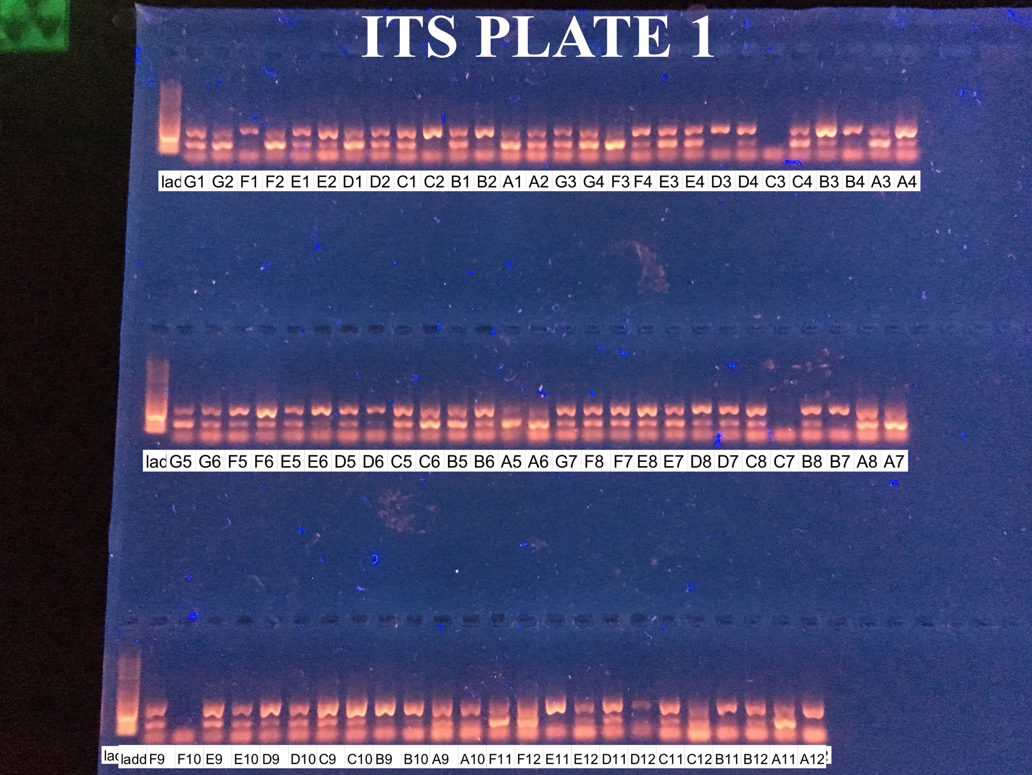

# Pooling your samples & gel extraction

* + - 1. “Eyeball” each barcoded band and decide how much of that sample to pool into final pooled library. A ‘normal’ band would have 5µl of that sample pooled, a ‘bright’ band would have 3µl pooled, and if a band is faint I would pool 10µl of that sample. For example, in the gel above, I would say G1 would have 5µl of sample added, C2 would have 3µl of sample added, and A1 would have 10µl added.
      2. If you had 96 samples to pool & 5µl per sample was pooled on average, you would now have a tube with ~500µl of pooled library. Remember that you can’t pool more than 96 samples because that’s the number of unique MiSeq barcodes we have.
      3. Clean 40µl of the pooled library using the GeneJET PCR Purification Kit. Elute with 40µl of elution buffer. (You run the risk of clogging the column if you clean too much of your pool, so play around with this step for your pool.)
      4. Make a 60ml 2% agarose gel, adding 6µl of SYBR green (should live in the enzyme box in the freezer). Use a 9-well comb and tape together two wells so you can run more library & cut out the band more easily.
      5. Clean out the gel box where you will be running your gel & fill it with brand new running buffer.
      6. Start by running 20µl of the cleaned pool in each of two lanes on your 2% gel at 70 V for at least 1.5 hours. Illuminate your gel on a blue light box (the UV box will damage your DNA). You may need to run for longer than 1.5 hours if you do not yet have sufficient separation between your target and & other non-specific bands, see right:
         1. If your band is super smeared, you have too much product, run 10µl on the gel next time.
      7. Using a sterilized (add 100% ethanol & flame it) razor blade, cut out target band (~500 bp). Use sterilized tweezers to collect in a 1.5ml tube. You should be throwing out a gel that now looks like this on the right:
      8. Soak the gel band in 20µl MilliQ water (or other nuclease-free water) at 4˚C overnight.
         1. Alternatively, you can use a commercial gel extraction kit.
      9. The next day, collect all the liquid that you can in a fresh tube. You can throw out the left behind gel bit.

# P5-P7 test to check that gel extraction worked

* + - 1. Set up PCR:

Reagent (1x)

H2O 6.6µl

10x Titaq Buffer 1µl

2.5mM dNTPs 1µl

P5 IC2 10µM 0.2µl

P7 IC1 10µM 0.2µl

TiTaq 0.2µl

Total: 9µl/reaction **plus**

1µl of library

* + - 1. Run PCR:

**P5-P7 PCR Profile**

95˚C for 5 min

12x 95°C for 40sec

63°C for 2min

72°C for 1min

* + - 1. Run 2 µl on 1% agarose rose with gel red (180V for 20 min)
      2. If successful amplification, PicoGreen for concentration. Protocol for PicoGreen assay is in the TagSeq protocol document.

# Submit for sequencing!

* + - 1. Each genomics center will have their own instructions. I would submit as much library as possible to avoid having to send more. Example spreadsheet for sending to Tufts is available in another document.

**Example Primer Sequences**

It’s fairly simple to create your own barcoded primers.  The target amplicon primers are slightly modified to include a linker that any of the remaining barcode primers can bind to. Barcodes can then be used for any amplicon target, so long as amplicon primers are properly modified. Dual barcoding is cost efficient – more samples with less barcodes – ex. 20 forward and 20 reverse barcodes can label up to 400 unique samples.  See <https://wikis.utexas.edu/display/GSAF/Illumina+-+all+flavors> for more primer examples and barcodes.

|  |  |  |
| --- | --- | --- |
| **Primer Name** | **Barcode** | **Sequence** |
| ITS2-F-miseq | n/a | Adaptor + Linker + **Pochon ITS2 Forward Primer**  TCG TCG GCA GCG TCA GAT GTG TAT AAG AGA CAG **GTGAATTGCAGAACTCCGTG** |
|  |  |  |
| ITS2-R-miseq | n/a | Adaptor + Linker + **Pochon ITS2 Reverse Primer**  GTC TCG TGG GCT CGG AGA TGT GTA TAA GAG ACAG **CCTCCGCTTACTTATATGCTT** |
|  |  |  |
| Hyb_F13_i5 | AGTCAA | Illumina (Nextera) Primer + Barcode + Forward Adaptor  AAT GAT ACG GCG ACC ACC GAG ATC TAC AC  AGTCAA T CGT CGG CAG CGT C |
|  |  |  |
| Hyb_R43_i7 | GCTGTA | Illumina (Nextera) Primer + Barcode + Reverse Adaptor  CAA GCA GAA GAC GGC ATA CGA GAT  GCTGTA GTC TCG TGG GCT CGG |